Operasional fluck-it.com/fluckit.com

1. **PAGE AWAL (LOG IN PAGE)**

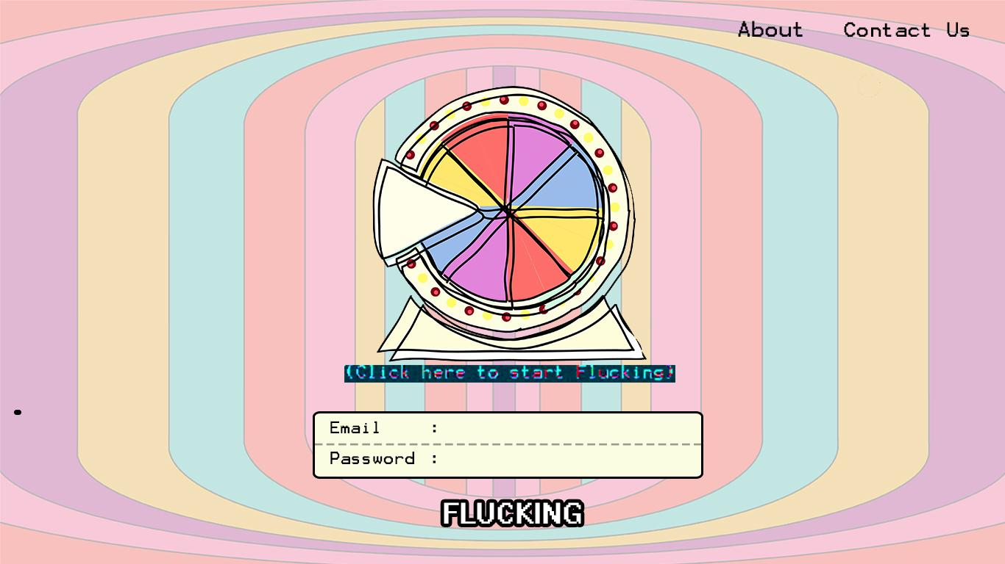

1. Email & password = bener kemudian click “Flucking” = masuk Genre Movie Page

2. Email & password = salah kemudian click “Flucking” = text “Flucking” =geter

3. About kalo di click = diem aja

4. Contact us kalo di click = diem aja

5. “ Click here to start flucking” kalo di click = masuk ke Sign Up Page

6. Password : (*******)

1. **Sign Up Page**

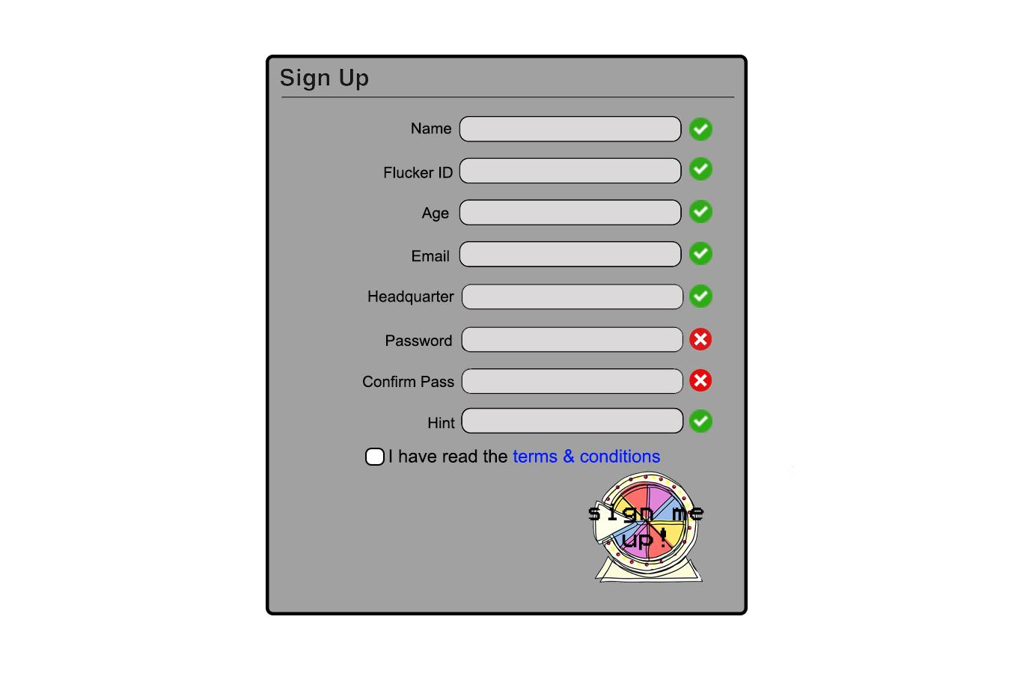

1. Kalo ada yang kosong = x merah

2. Kalo “Flucker Id” masih tersedia (username) = ceklist

3. Password min 8 character ( kalo kurang insert text “ minimum 8 character”

4. “Confirm Pass” salah = x merah

5. “Terms and conditions” click = “Terms and condition page”

6. “ I have read the terms and conditions” click = check list dalam box

7. “Sign me up” click = lanjut ke “Manage profile page” (jika semua sudah terpenuhi)

1. Manage Profile (Register)

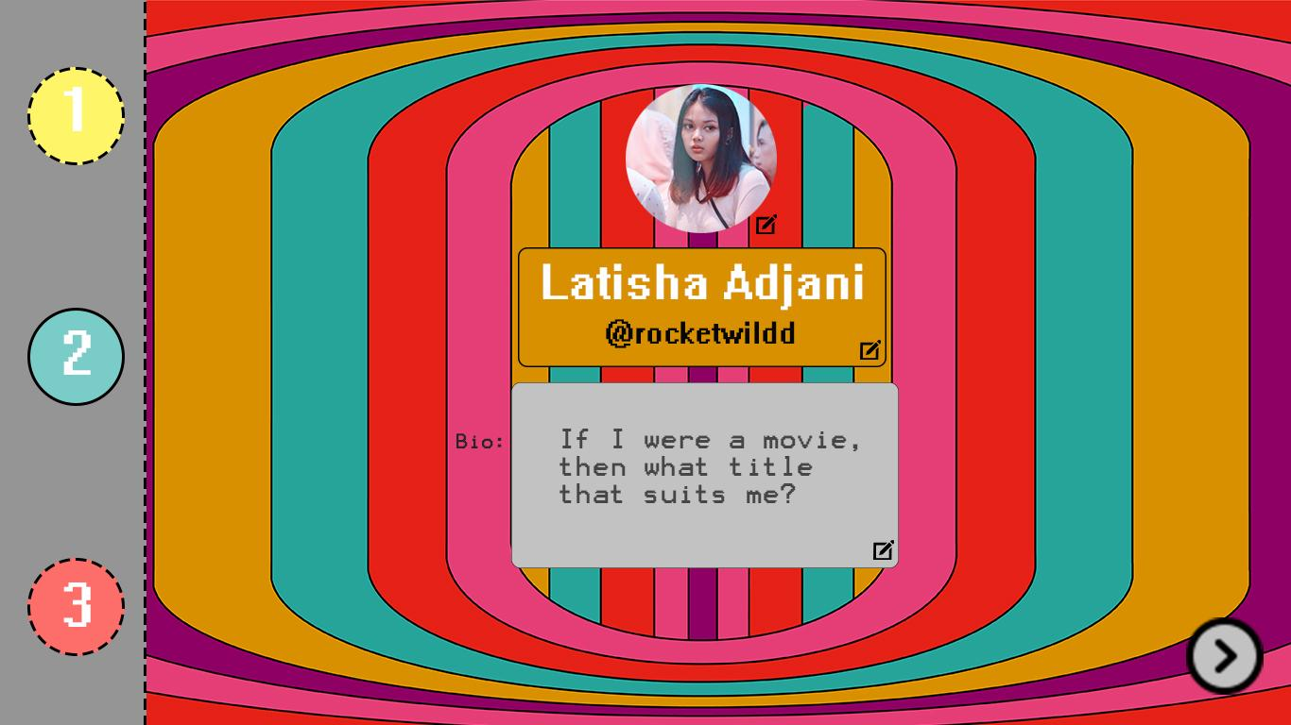

1. Profile picture di click = pop up logo pensil (edit) kalo di click = import file (auto resolution)

2. Name & username click = pop up logo pensil kalo di click = edit nama

3. Bio (text boxt) click = pop up logo pensil kalo di click = edit bio

4. Panah/Next click = pindah ke “Favorite Genre”

5. Angka 1 disebelah kiri garis-garis pada buletannya menjadi bold angka 2nya titik titik.

1. Favorite Genre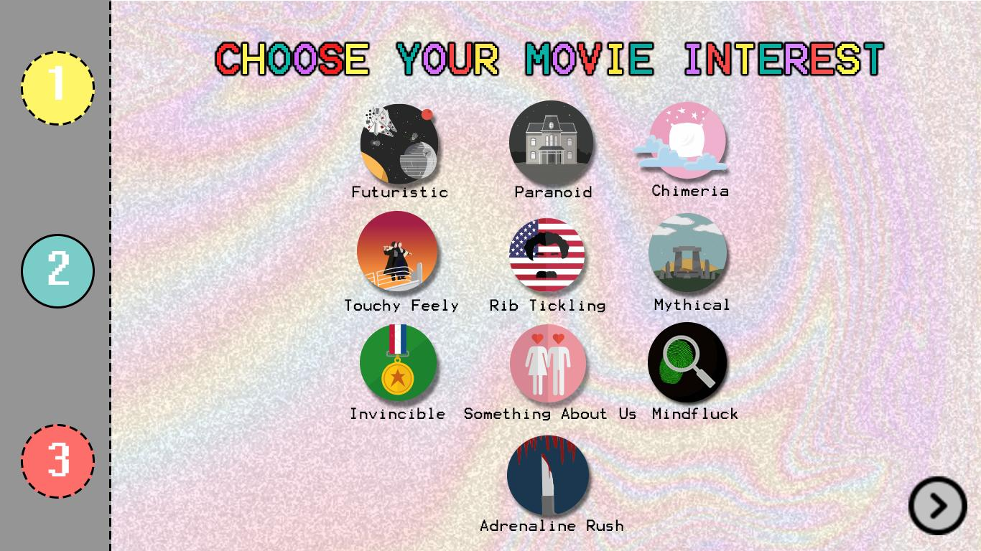

1. Setiap logo di click = pop up min 1 (max 3)

2. Next / Panah di click = pindah ke “Find Friends Page”

3. Movie interest yang dipilih muncul di profile page (halaman 10)

1. Find Friends Page

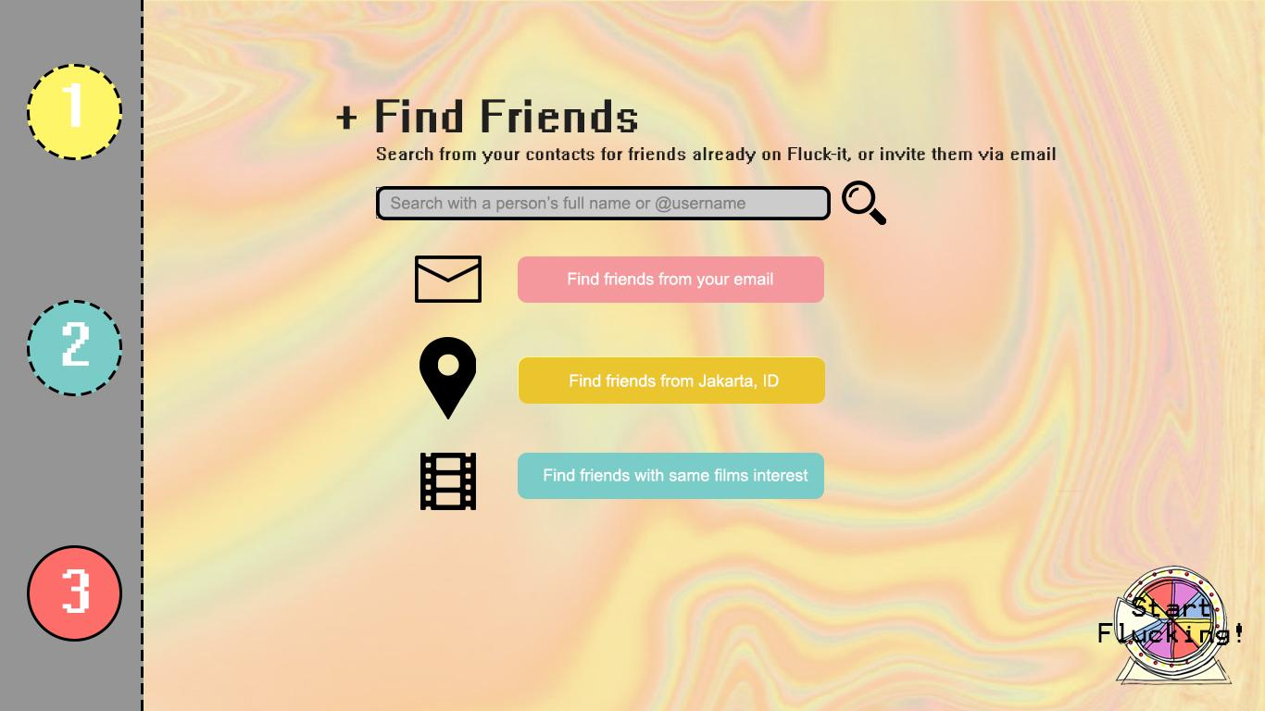

1. Semua di click = pop up text “ oops stay tune folks”

2. Logo “Start Flucking” Click = pindah ke page “Welcome Fluckers” page

1. Welcome Fluckers



1. Hanya minimal 8 detik (Tergantung kecepatan internet)

2. Lanjut ke Select Genre & Educational Interest “ Page

1. Select Genre & Educational interest Page

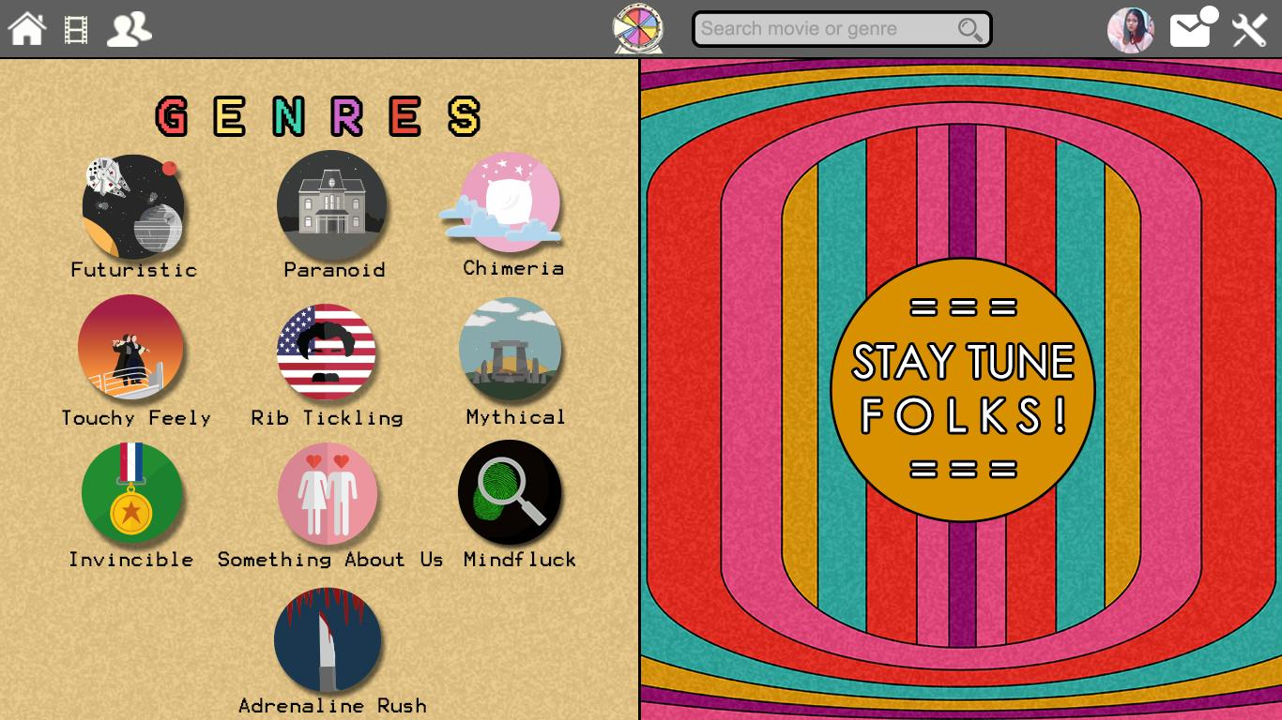

1. Logo Home di click = pop up text “oops”

2. Logo Movie di click = “Select Genre & Educational interest page”

3. Logo 2 orang = pop up text “ oops”

4. Logo Fluck-it (wheel of fortune yang ditengah atas) click = lanjut ke movie profile page secara random)

5. Search engine click = pop up “oops”

6. Avatar/Profile picture click = “Profile (edit) page”

1. Movie genre list page

1. Poster di click = masuk ke “movie profile” page

2. Judul di click = masuk ke “ movie profile” page

3. Logo Genre yang sedang di buka logo berwarna

4. Logo Genre yang tidak di buka blur

5. Logo Genre yang blur ketika cursor mengarah ke logo genre tersebut maka logo genre menjadi jelas

6. Logo genre yang jelas kemudian di click = berpindah ke “movie genre list” (tergantung genre)

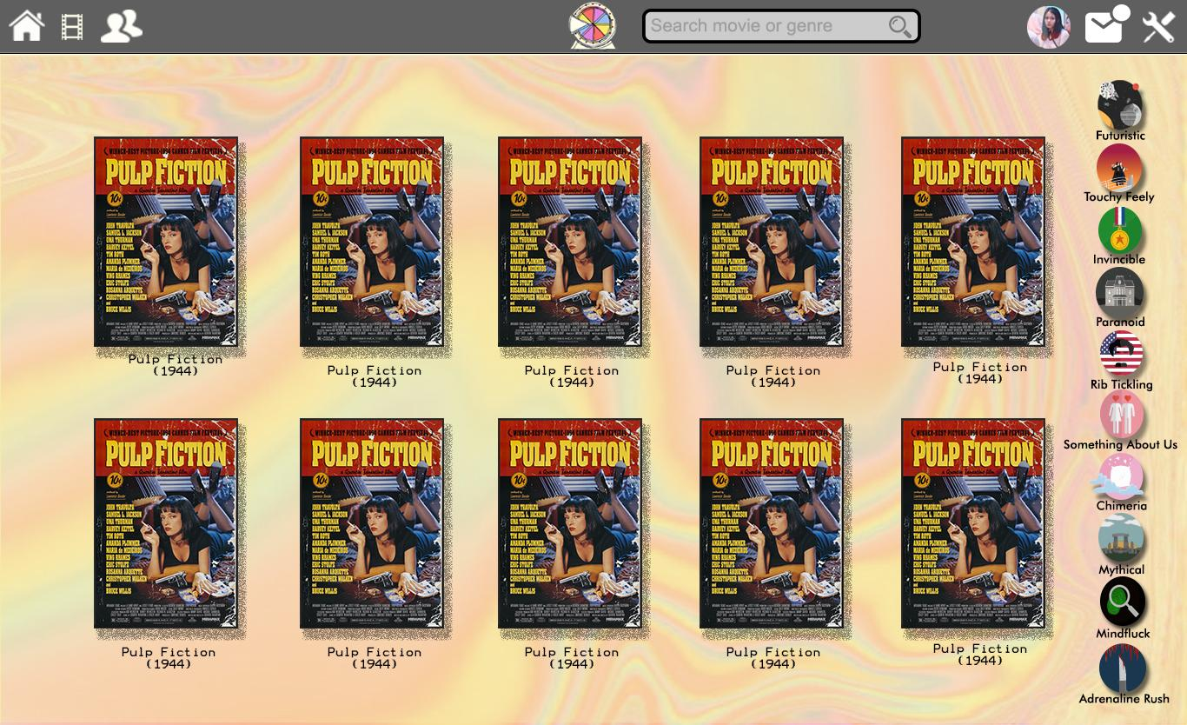



(contoh blur)

1. Movie profile



1. Trailer source = Youtube.com ( link sudah diberikan di database movie)

2. Poster/Judul film yang berada dibawah tulisan “you may also like” apabila di click = masuk ke “movie profile page” film tersebut

3. You may also like merupakan rekomendasi film dari genre yang sama (sudah disediakan pada database)

1. Profile Page (edit)

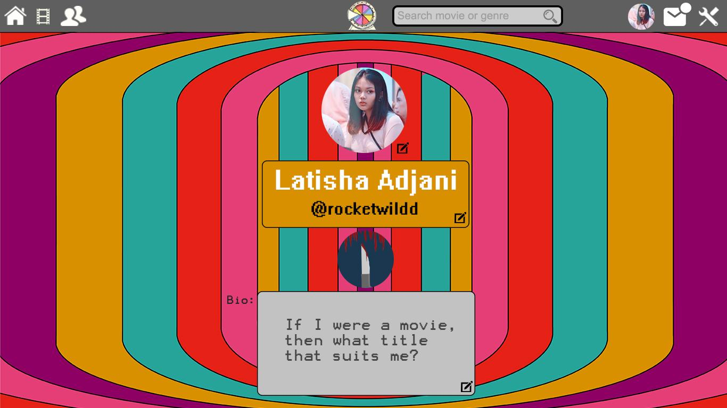

1. Profile picture di click gambar pensil ( ganti profile picture)

2. Nama di click gambar pensil ganti nama

3. bio di click gambar pensil = ganti bio.